# *WORDPRESS HOSTING*

WordPress is a free and open-source content management system (CMS) that allows users to create and manage websites and blogs. It's one of the most popular website-building platforms.

The AWS Services that is needed to host the Wordpress are:

* Create VPC and their subnet, Route table and internet gateway
* Create RDS
* Create S3 Bucket
* Create DB Subnet group
* Create EC2 Instance

Let’s get started, first Go to the AWS Management Console at https://console.aws.amazon.com/ and sign in with your AWS account credentials. Once logged in, navigate to the "Services" menu at the top of the page and select "VPC" under the "Networking & Content Delivery" section. This will take you to the VPC Dashboard. In the VPC Dashboard, click on the "Create VPC" button to start the VPC creation

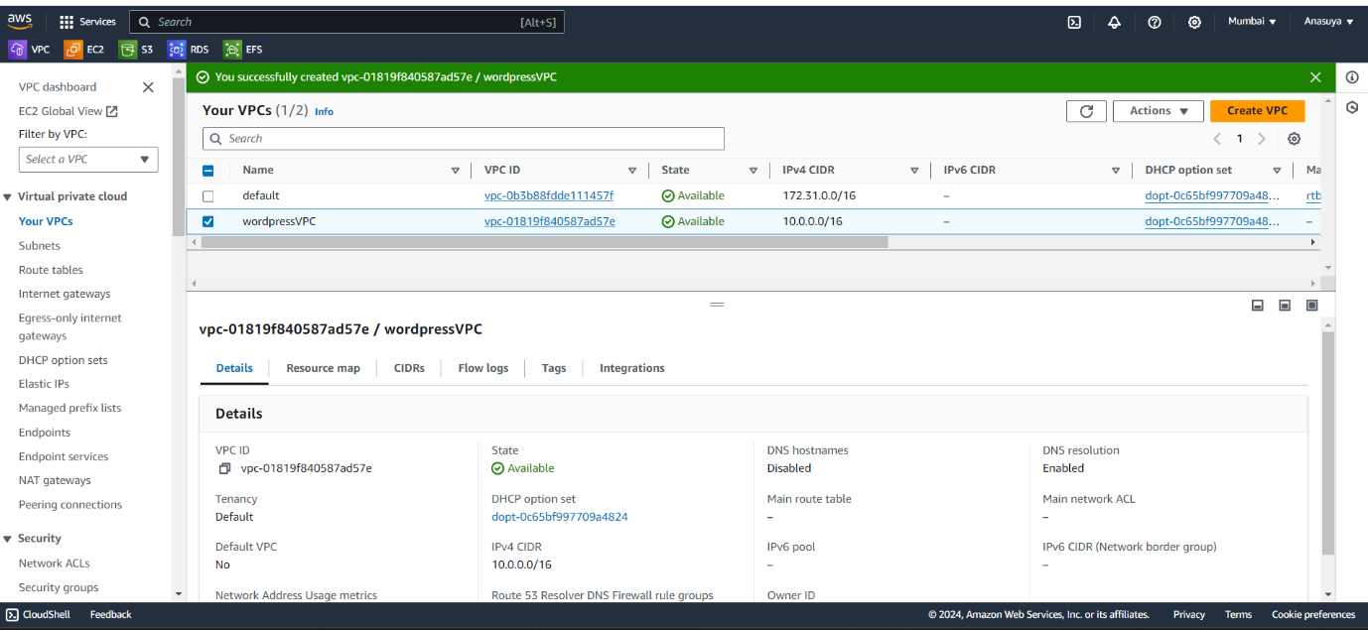

After creating VPC, create 2 subnets - one being private subnet and one being public subnet.

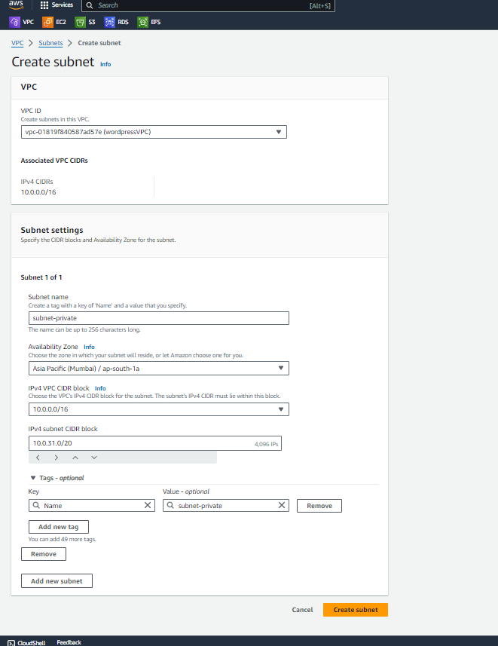

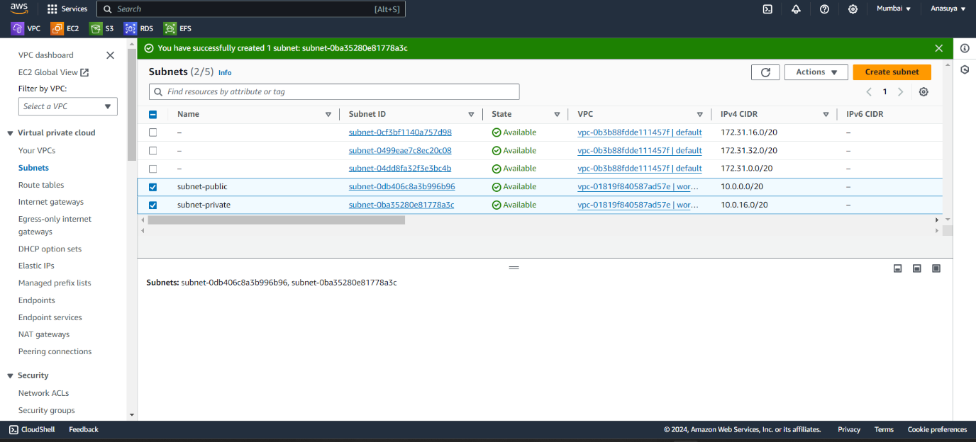

Create a Route table for each subnets.

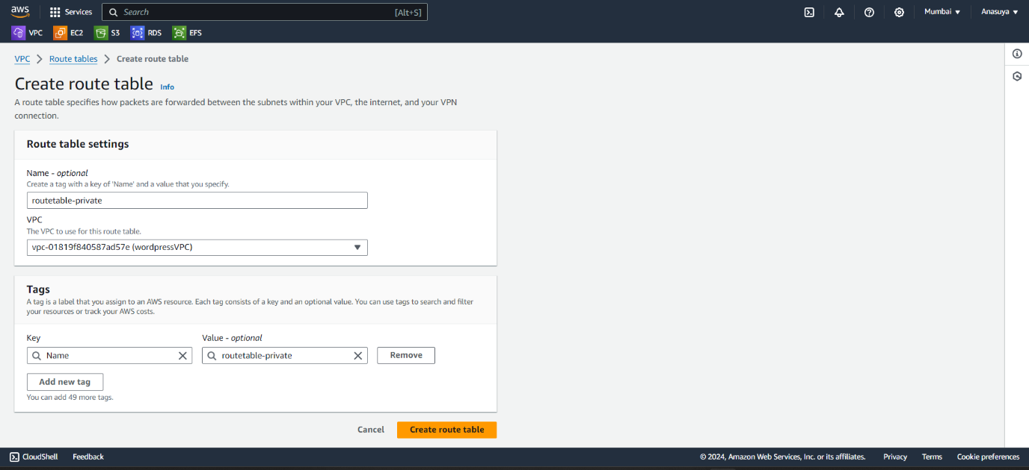

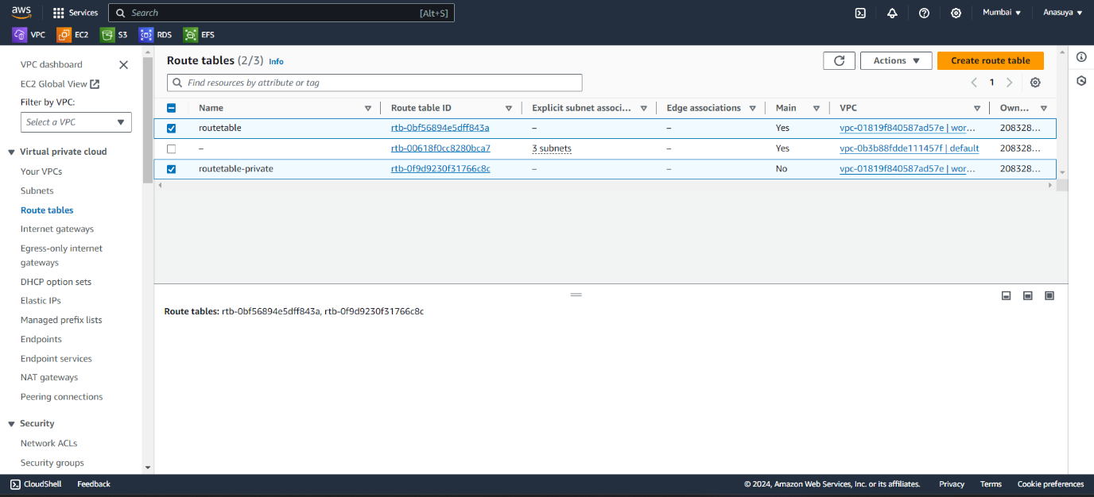

For public subnet, create an Internet Gateway and attach the internet gateway with VPC. Add Internet way id to main route table, Select route table and go to edit routes in that add destination as 0.0.0.0/0 and past your internet gateway id in target and save the changes.

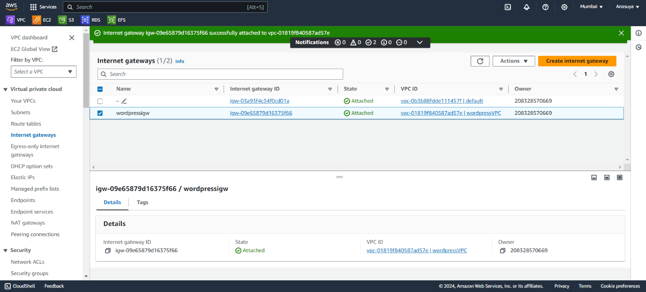

For Private subnet, you don’t have to create internet gateway. Next create an instance and launch it.

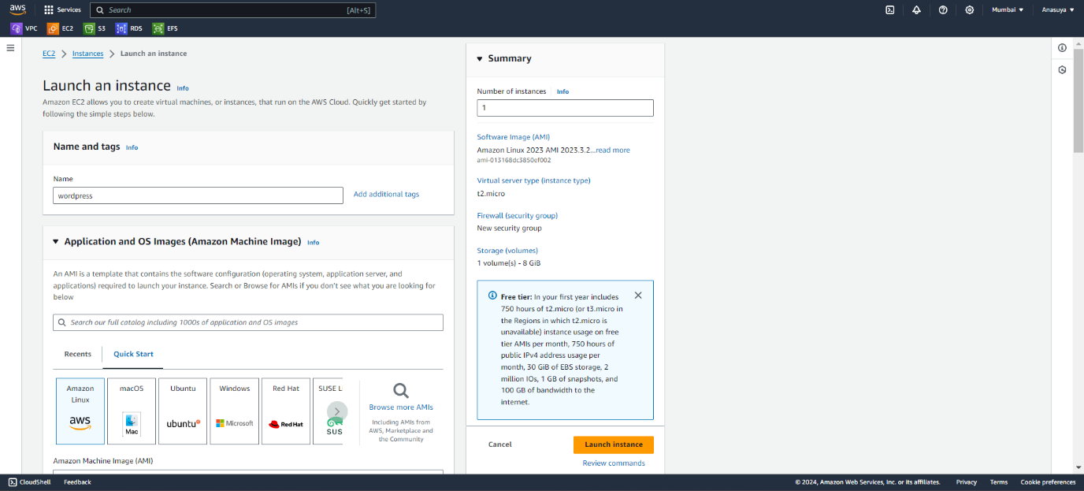

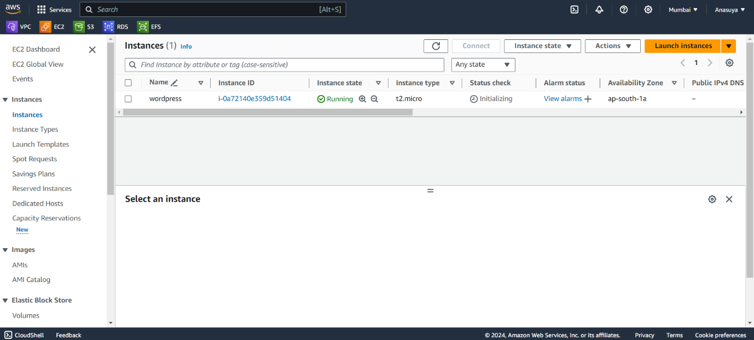

Before Creating RDS, First create a subnet group consisting of only private subnets in RDS.

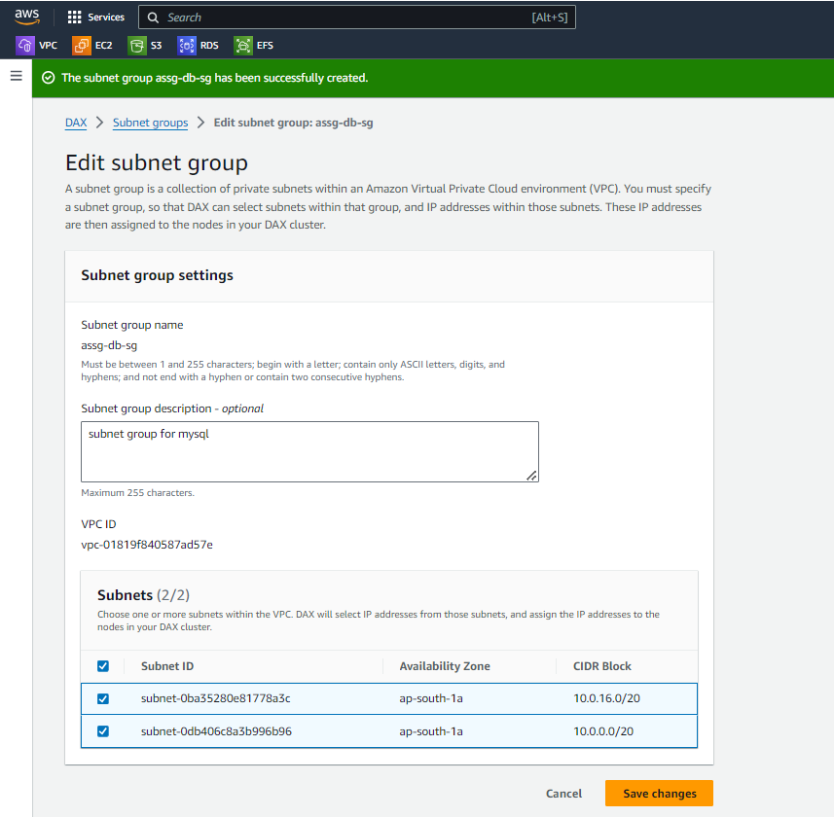

Next Create database by click on create database.

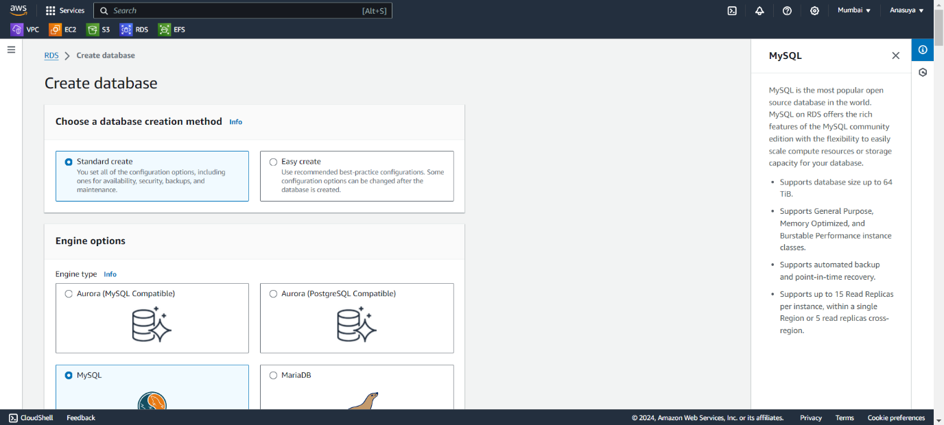

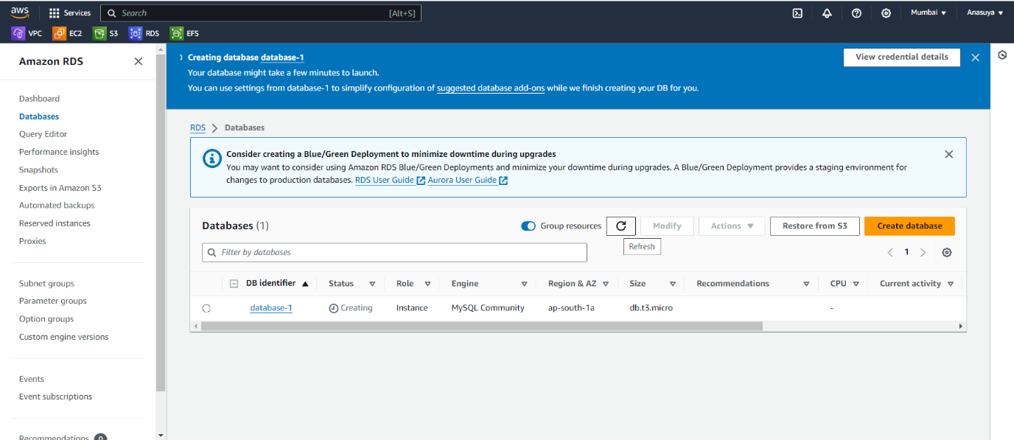

Create an S3 bucket with unique name Step 1 – Search S3 in search bar and create an S3 bucket with the “assg-bucket-” name.

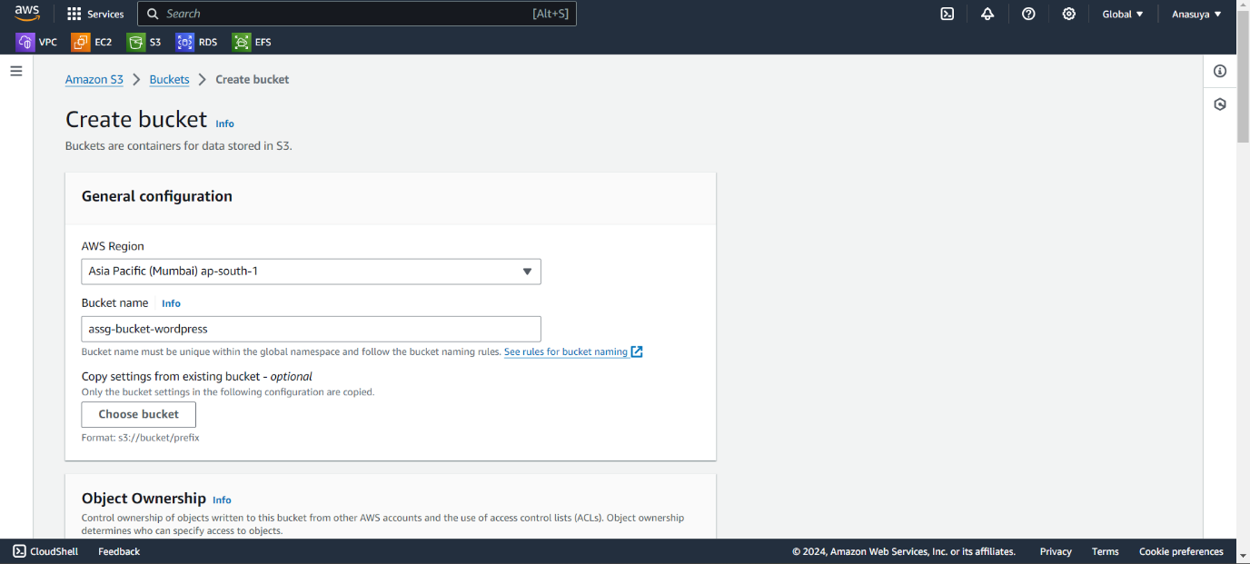

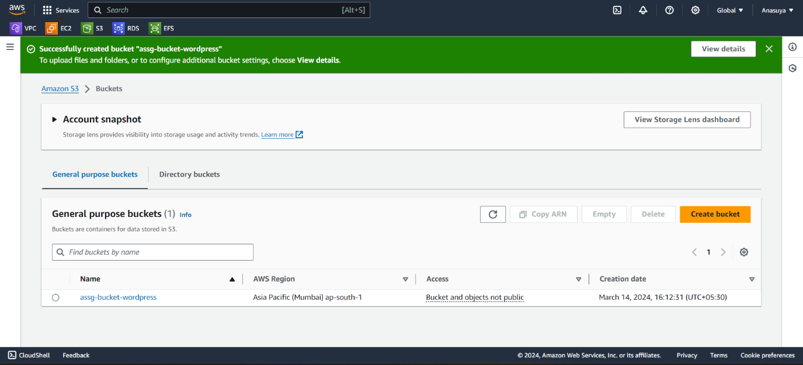

Now, we will continue further and modify security group of RDS and EC2 instance. So, we need EC2 instance. So please go ahead and create EC2 instance and all missing AWS resources which we created so far. • select instance, • Click Edit inbound rules button • Click Add rule, For Type, select MYSQL/Aurora, • For Source, select Anywhere in ipv4 , and click Save rules • Click Add rule, For Type, select HTTP, • For Source, select Anywhere in ipv4, and click Save rules

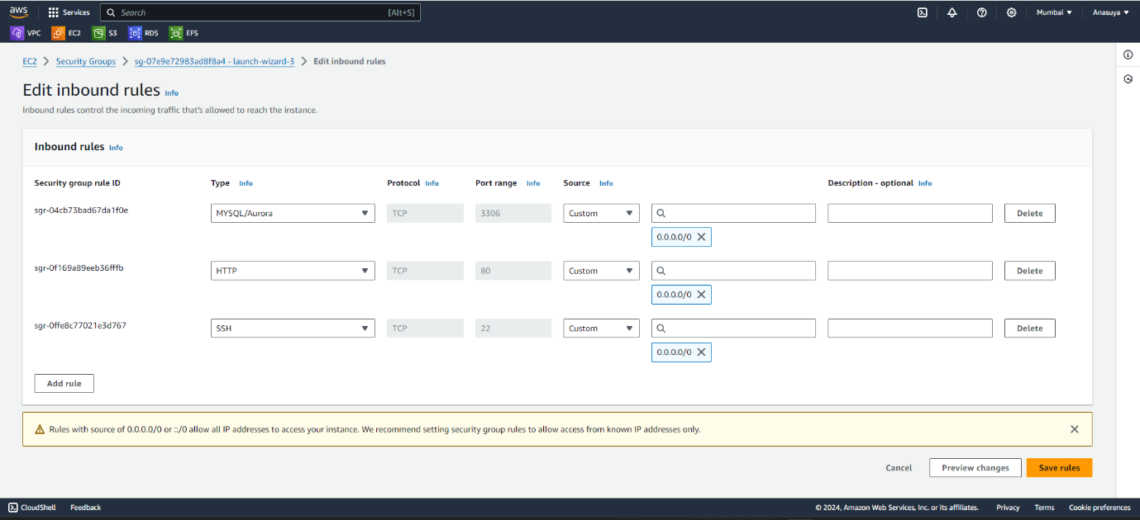

Now Set Up the Wordpess Environment

Select the Public instance and click Connect, • In Connect to instance page, click SSH client on menu and you can find the connection command in Example. • Windows User: follow the step in this deck to connect EC2 instance by Putty • MacOS User: open a terminal on your computer, navigate to the folder where your.pem key file is stored, and paste the connection command.

After connection successes, run the following command to install LAMP stack (Linux, Apache, Mariadb and php) on your instance:

* sudo yum install httpd -y | sudo service httpd start | sudo service httpd status
* sudo yum install mariadb* | sudo service mariadb* | sudo service mariadb* status
* sudo amazon-linux-extras install php8.0 | sudo service php-fpm start | sudo service php-fpm status
* sudo service httpd restart | sudo service mariadb* restart | sudo service php-fpm restart

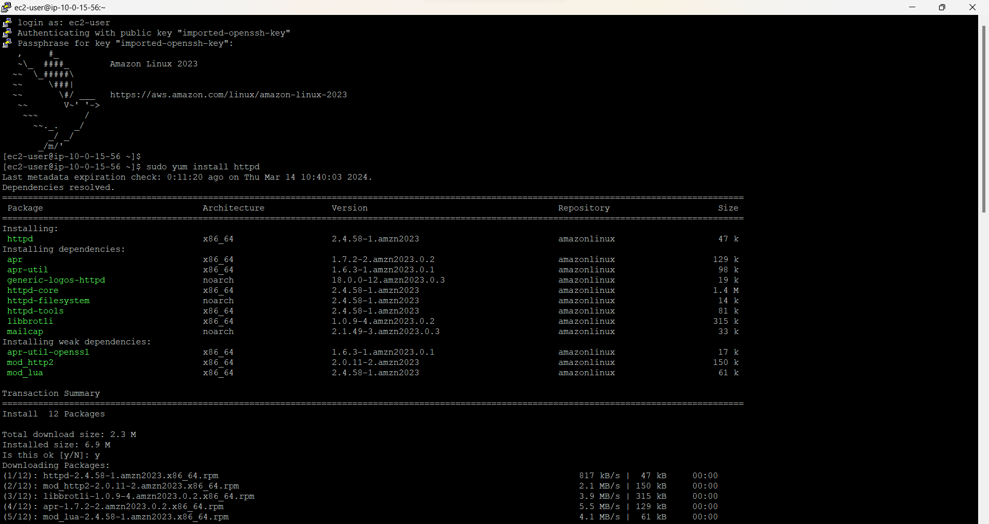

Now Set the environment variable of MySQL in your computer, replace to the endpoint which can be found in RDS console→ your database. o sudo mysql -h -u -p

create a database called database1

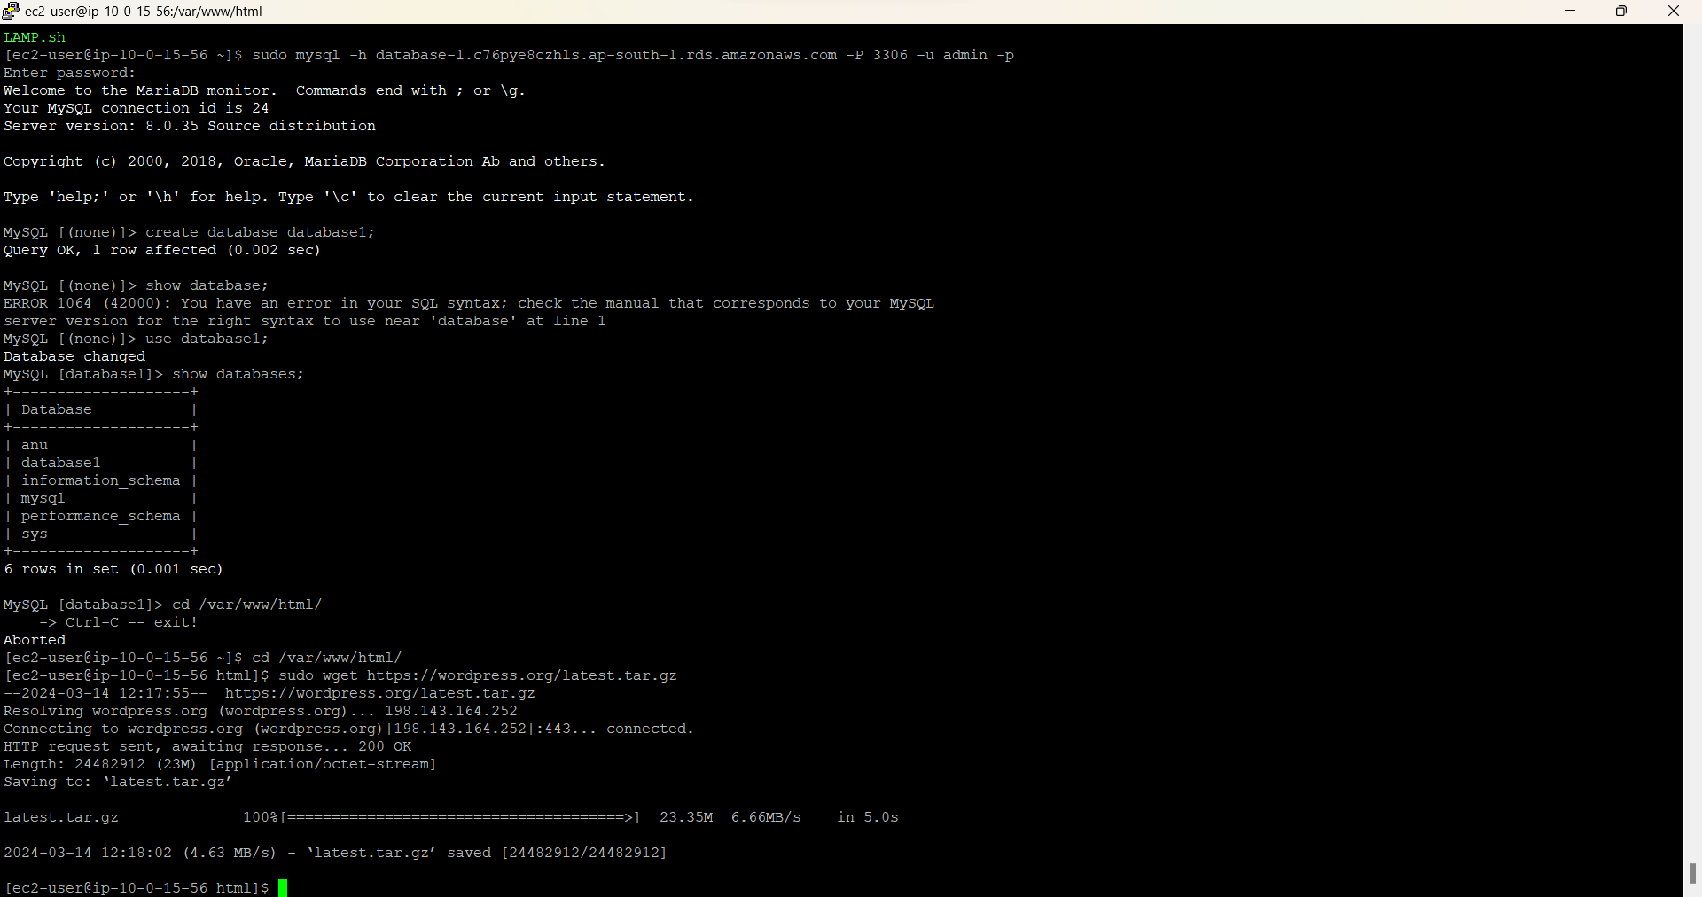

Go to html using path cd /var/www/html then, download the WordPress module and unzip it .

* sudo wget <https://wordpress.org/latest.tar.gz>
* sudo tar -xzf latest.tar.gz

Next Move into WordPress folder and backup the default config file

* cd wordpress
* cp wp-config-sample.php wp-config.php

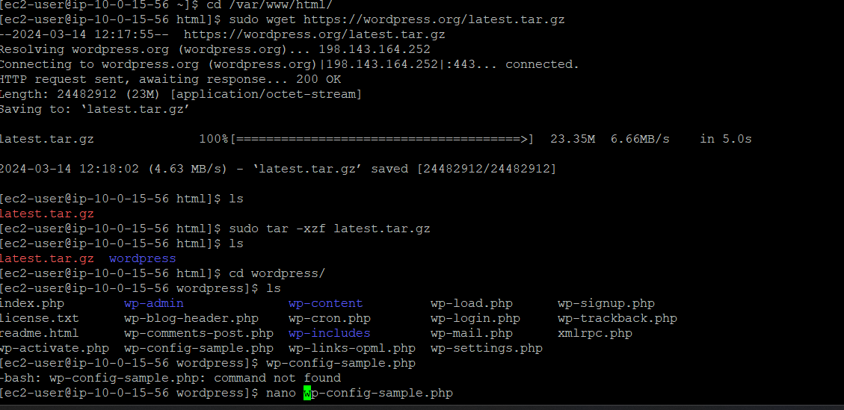

After that use nano to edit the wp-config.php file -- sudo nano wp-config-sample.php

Modify the following script into the correct value:

* DB_NAME: 'wordpress'
* DB_USER: 'wordpress'
* DB_PASSWORD: 'wordpress-pass'
* DB_HOST: your RDS endpoint and save it.

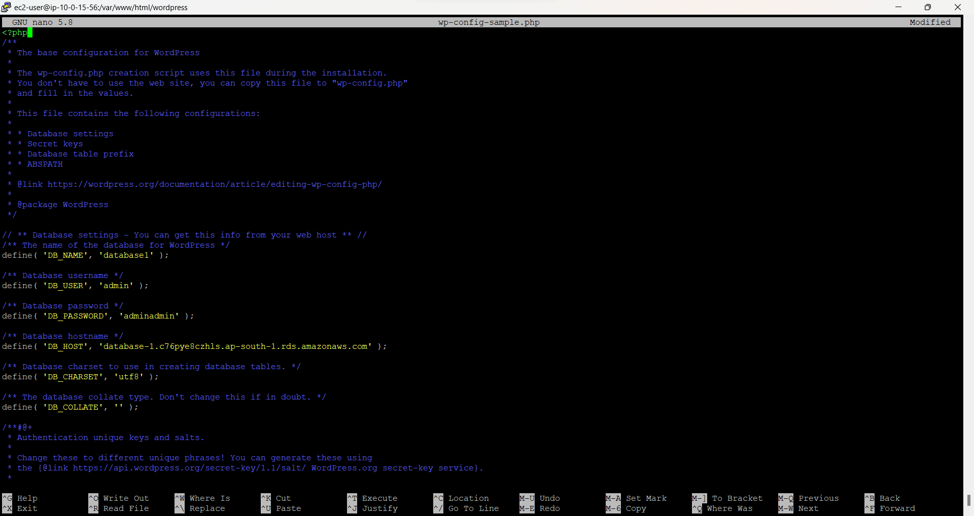

Select the EC2 instance, and find the Public IPv4 DNS in Details below and paste it on your browser, then you will see the setup page of WordPress.

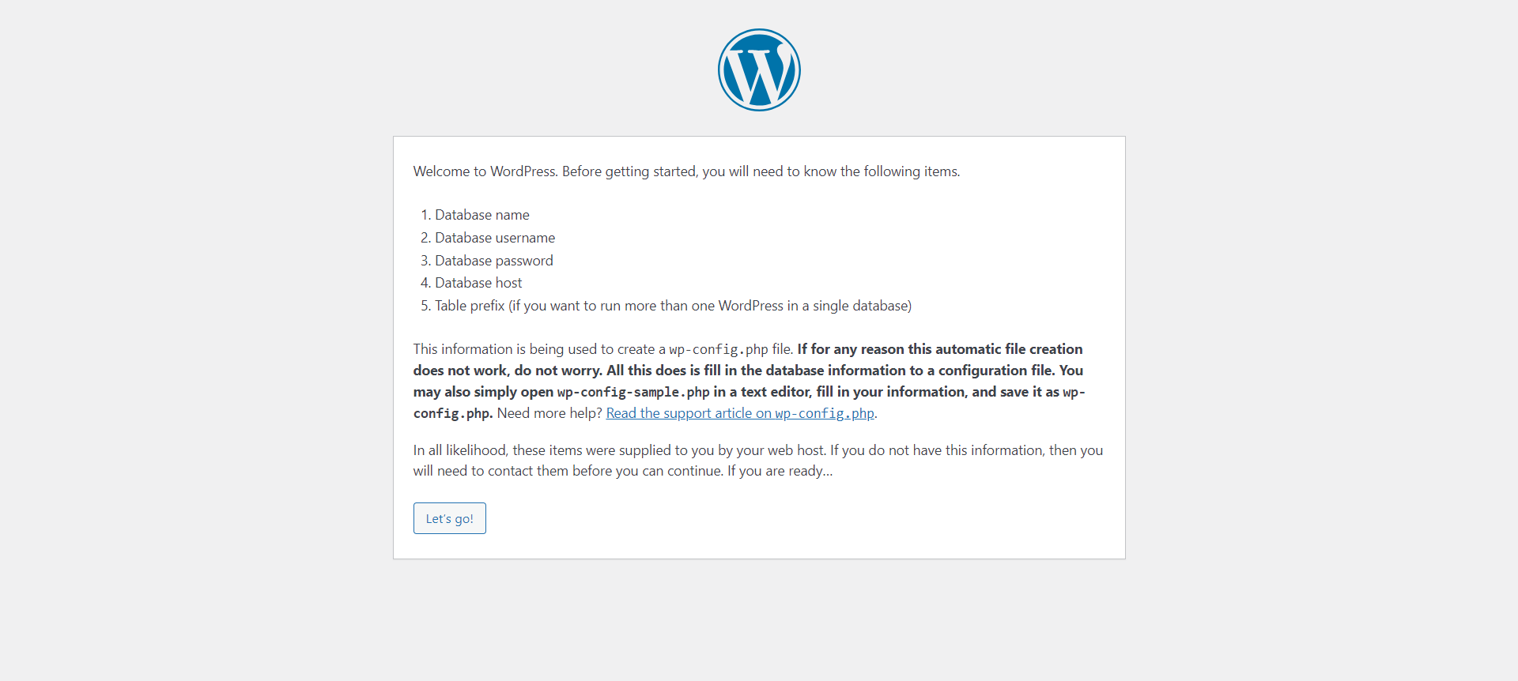

In setup page, enter your own value in the Site Title, Username, Password and Your Email, then click Install WordPress after that Now, you can view your blog in .

Congratulations, you have successfully hosted a simple WordPress website on EC2 instance and configured all required AWS services.

